1

About MENA HPF

3

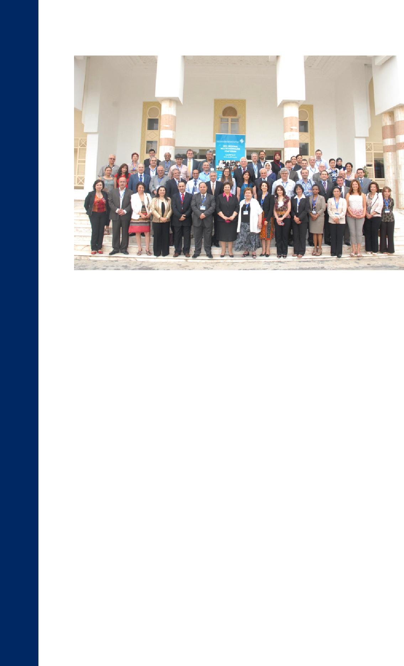

Participants of Tunis Regional Symposium

Profile and History

Introduction:

The Middle East and North Africa Health Policy Forum (MENA HPF) was established in March 2008 as an independent, nonprofit organization to promote the generation and use of knowledge to enhance evidence-based health policies to better the health of citizens of the MENA region, in particular the most disadvantaged. The MENA HPF was originally registered under paragraph 60 ff. of the Swiss Civil Code, with its legal headquarters in Zurich, Switzerland. As of March 2016, the Forum has received approval from Ministry of Foreign Affairs and Minstry of Social Solidarity and is now registered in Egypt as an independent foreign NGO under law 84 for year 2002 of the Egyptian law. The MENA HPF is a membership-based and driven organization with members drawn from health policy researchers and experts from MENA countries. The key contributors to the MENA HPF are the British Department of Health, the World Bank, and the Regional Office for the Eastern Mediterranean of the World Health Organization (WHO EMRO).

The key constituencies for the MENA HPF are policymakers, academic experts, service managers, healthcare practitioners, non-governmental organizations, and researchers.

As the only independent organization of such nature in the region, the MENA HPF has a clear comparative advantage and value; it is in a position to promote and enhance the development of better health policies through the inclusion of multiple partners at the regional and individual country levels, including universities and the private sector. This multisectoral reach and targeting has the potential to improve cooperation and communication between researchers and policymakers.

To this end, the Forum seeks to influence policy development and dialogue by commissioning and disseminating high quality, original policy‐relevant research and analysis; building the national and regional capacity for sound, relevant, independent policy research and analysis; and facilitating networking and the exchange of ideas and experiences among those with an interest in health policy.

BACKGROUND AND CONTEXT

1.1 The problem

Health systems in the MENA region continue to face myriad challenges that collectively result in inadequate and inequitable health outcomes, insufficient human capital development, and, in the long run, reduced economic growth. Despite efforts to improve their performance, the health systems in these countries continue to be plagued, in particular, by inadequate and inequitable access to care. Moreover, healthcare services tend to be inefficiently provided and of poor technical quality. In the public sector, this problem is compounded by poor service quality, causing many, including the poor, to seek care in the private sector, which, in cases of catastrophic illness, contributes to the impoverishment of all but the wealthiest population groups. With an increasing burden of disease due to chronic illnesses, the countries in the region are poorly equipped to meet the new challenges caused by the aging of their populations and the emergence of new scourges such as HIV/AIDS.

1.2 Toward an explanation

Many factors contribute to the poor performance of health systems in the region, but particularly significant is the lack of a capacity in evidence‐based, strategic decision and policy making, which is due in part to a dearth of systematic research and analysis of health sector challenges in the region, limited or non‐existent data, and an inadequate human resource capacity to conduct applied health policy research and analysis. Even when research and analysis exist, their findings are rarely used to guide the development of national health policies, nor are they shared with other countries in the region.

1.3 Why respond?

There is good reason to respond to these challenges at a regional level. The determination of health outcomes is multifaceted, implicating not only the health system, but also the educational and the social environment. Given similarities in these underlying determinants across the region, research and analysis will often more efficiently be commissioned and undertaken at a regional level. In addition, a number of health policy problems have a regional character—for example, the procurement of a trained health workforce and pharmaceuticals— and can be fruitfully tackled comparatively or collectively in order to overcome resistance to change by vested interests, both commercial and professional. Most importantly, a strong,

5

independent critique from a body with a regional scope and reputation has the potential to be a powerful catalyst for change even in countries lacking a strong domestic civil society, so long as the critique is sensitive to the factors that have impeded good policy making and effective implementation in the past. A substantial improvement in human resource capacity to analyze health policy and strategic solutions may yield a high cost-benefit outcome.

DEVELOPMENT OF THE INITIATIVE: MENA HEALTH POLICY FORUM

The Forum held its launch conference, “Better Policies for Better Health,” in Cairo in September 2007, co‐funded by the World Bank, WHO, IDRC, and the British Department of Health (DH). The conference was attended by over 100 senior health policy experts, civil servants, presidential advisors, and ministers from a dozen countries around the region, including Egypt, Palestine, Lebanon, and Yemen, as well as representatives from international and donor organizations such as the World Bank, WHO, IDRC, DH, USAID, and the EU. The Forum presented interim findings on research priorities to the conference and identified priorities.

In March 2008, the Forum established itself as a non‐profit association in Zurich.

The workshop, the interim work of the task force, and the first formal meeting of the Forum were all sponsored by the British Department of Health, as part of the British government’s concern for the promotion of the welfare of the less advantaged populations of the region, the development of civil society institutions, and the professional development of potential agents for change.

As of March 2016, the forum is registered in Egypt as an independent foreign NGO under law 84 for year 2002 of the Egyptian law.

FORUM MISSION, AIMS, AND INTENDED OUTPUTS

In response to the identified needs pertaining to evidence-based health policies in the MENA region, some three dozen academics and health policy experts from across the region initiated the MENA HPF.

The stated aim of the Forum is to contribute, especially in the low- and middle-income countries of the region, to the development of effective, efficient, equitable, and sustainable policies that improve health and/or mitigate the adverse consequences of ill health, particularly for those who are most disadvantaged. Our focus is on the macro level features of health systems and policy and the use of evidence.

The Forum seeks to have an impact upon policy formulation by:

- Supporting the development of accessible datasets for the comparative analysis of health policy issues and in order to monitor the effectiveness of health policy reforms.
- Supporting the building of analytical and policymaking capacities in the region through workshops, seminars, and occasional internships.

- Commissioning and disseminating high quality, original research and analysis of health policy questions.

- Providing a venue for networking and the exchange of ideas and experience among those with an interest in health policy.

- Establishing a website to make accessible Forum papers, resources, and links.

The Forum prioritizes research that is likely to have a high impact on achieving the its aim; it will therefore focus on tackling problems that affect a large segment of the population, appear amenable to a resolution, and have policy relevance and regional importance. The relevance and impact of the research and analysis will be a priority and require sensitivity to the political and economic determinants of decision-making, distributional issues, the political calculus (winner/loser analysis; political sustainability), alternative policy options, implementation issues, and budgetary implications and affordability.

It also actively engages with policymakers at the early stage of project development to integrate their concerns and priorities—though without compromising independence and integrity—and gain access to relevant data. Impact is assured through a reputation for research and analysis of the highest quality. It thus establishes a quality assurance process involving independent peer review of projects, both at the proposal and final‐draft stages, for papers commissioned from experts in the field and those arising from competitive tenders among regional researchers.

The Forum maximizes the impact of its work by disseminating it through various venues, including conferences, workshops, and seminars with all relevant stakeholders, press releases and direct media outreach, the publication of its research and policy analysis, the creation a website, and, at a later stage, the establishment of affiliated country chapters.

7

MISSION-RELATED ACTIVITIES IMPLEMENTED TO DATE

The primary funders are the World Bank, the British DH, WHO, IDRC.

- Hosted 12 regional conferences and several workshops over the past years in Cairo, Damascus, Beirut, Amman and Tunisia.

- Commissioned research on equity in health (2010), equality in healthcare (2010), primary healthcare (2013), political economies of health (2013), health financing (2013– 14), research gaps in political and health systems (2014–16), efforts at governance in the MENA region (2014–15), assessment of health system governance in Egypt (2014– 15), harmonizing youth health and reproductive health services (2015), Ebola regional risk assessment (2014), and developed a three year strategic plan for the forum.

- Developed a film, “Voice of the People in Health: Aspirations for the Future,” reflecting real voices on the ground in Tunisia, Yemen, and Egypt following the Arab Spring.

- Participated in several international and regional conferences including the World Health Summit in Berlin (2012), Germany (2013); Council on Health Research for Development, “Boosting Research for Health in the Arab World,” held in Bellagio, Italy (2013); “Regional Priorities and Governance and Accountability in Health in the MENA Region,” Middle East Medical Assembly in Beirut, Lebanon (2013); Women’s Leaders in Algeria (2014); and WHO/EMRO regional workshops (2014-2015).

- Solicited the submission of research proposals on the topic “Affordable Priorities toward Universal Health Coverage,” as one relevant policy research area. A number of proposals were peer reviewed and two were selected.

- With WHO/EMRO, the Forum developed and constructed materials for regional capacity building for health economics (2015).

- With World Bank the forum developed the following:-

- Risk assessment of the introduction of Ebola into the MENA region: Directives for preparedness and prevention
- Briefing note on the Political Economy of Health in the MENA Region
- Health Policy and Systems Research: Evidence Gap Map in 15 Countries of the Eastern Mediterranean Region
- A Glance on Efforts to Strengthen Healthcare Governance in the MENA Region
- Governance Initiatives in Egypt's Healthcare Sector: Five Case Studies
- Health System Governance Assessment in the MENA Region-An Exploratory Methodology

- With UNFPA/ASRO, the Forum developed a regional report mapping sexual and reproductive health laws and policies in selected Arab countries (2016).

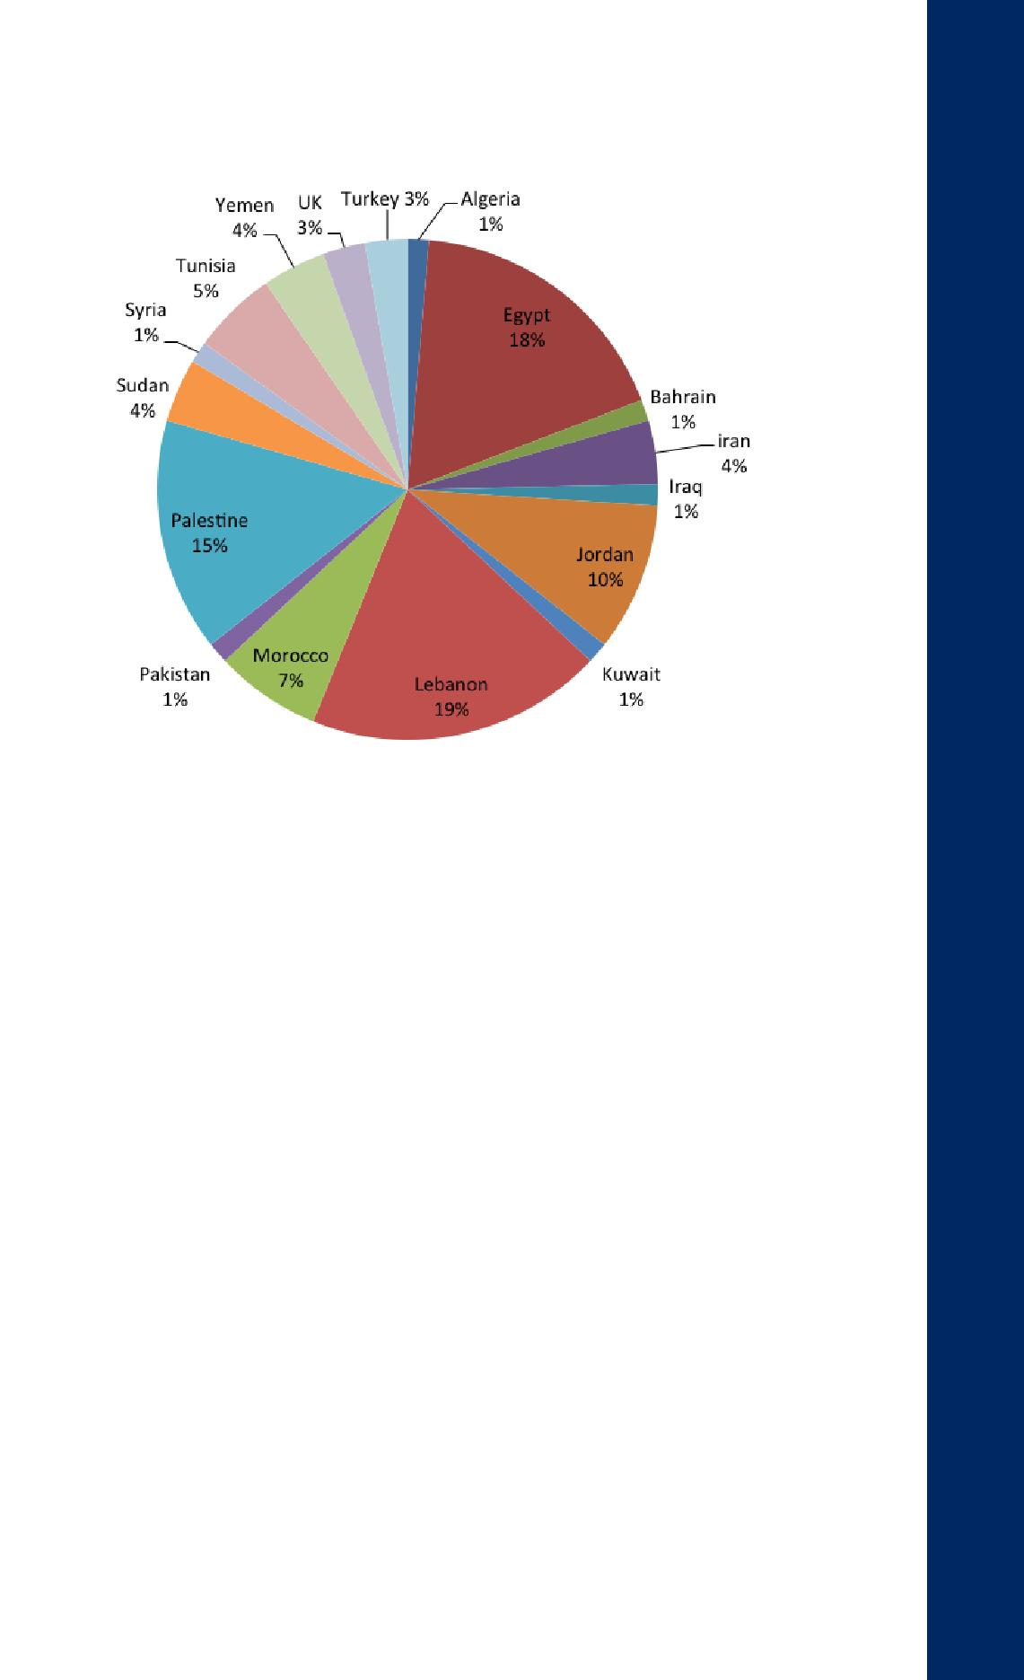

Current Membership Distribution by by Country

5.0 GOVERNANCE, ORGANIZATION, AND MEMBERSHIP BASE

The MENA HPF is a membership-driven organization; it currently comprises 70 members from 14 countries in the region who are health-policy experts covering a range of relevant disciplines and actual and potential sponsors.

The first elected chair of the Forum was Dr. Ahmed Galal, the managing director of the respected Economic Research Forum, a regional research institution covering the Arab countries, Iran, and Turkey.

Currently the MENA HPF chairperson is Dr. Salwa Najjab, director of the Juzoor Foundation for Health and Social Development. It has a functioning board of trustees headed by Dr. Salwa Najjab and comprised of 13 board members. The MENA HPF mandate is supported by an advisory committee of subject-matter experts drawn from the Forum membership and independent individuals. The Advisory Committee is one of the main Forum bodies, nominating potential members and advising the board of trustees on technical matters related to the advancement of the mission.

More information about the MENA HPF can be found at our website: www.menahpf.org

9

www.menahpf.org

